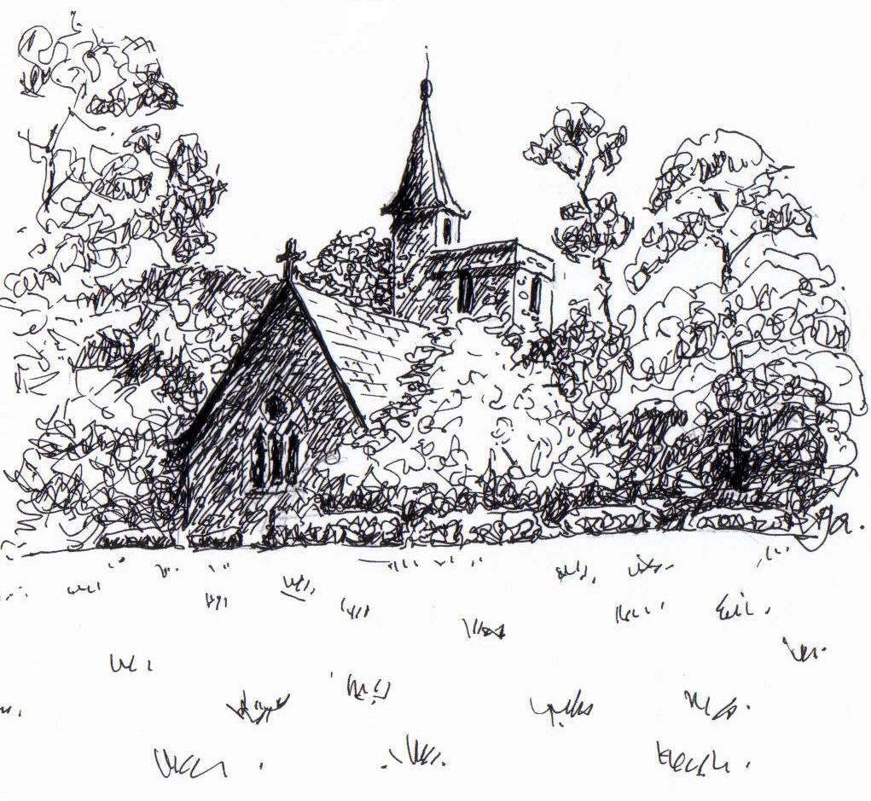
PARISH NEWS
The Deverills & Crockerton

Church of St Mary the Virgin, Kingston Deverill, from the west
by Pat Armstrong

April 2009

Look inside for local information

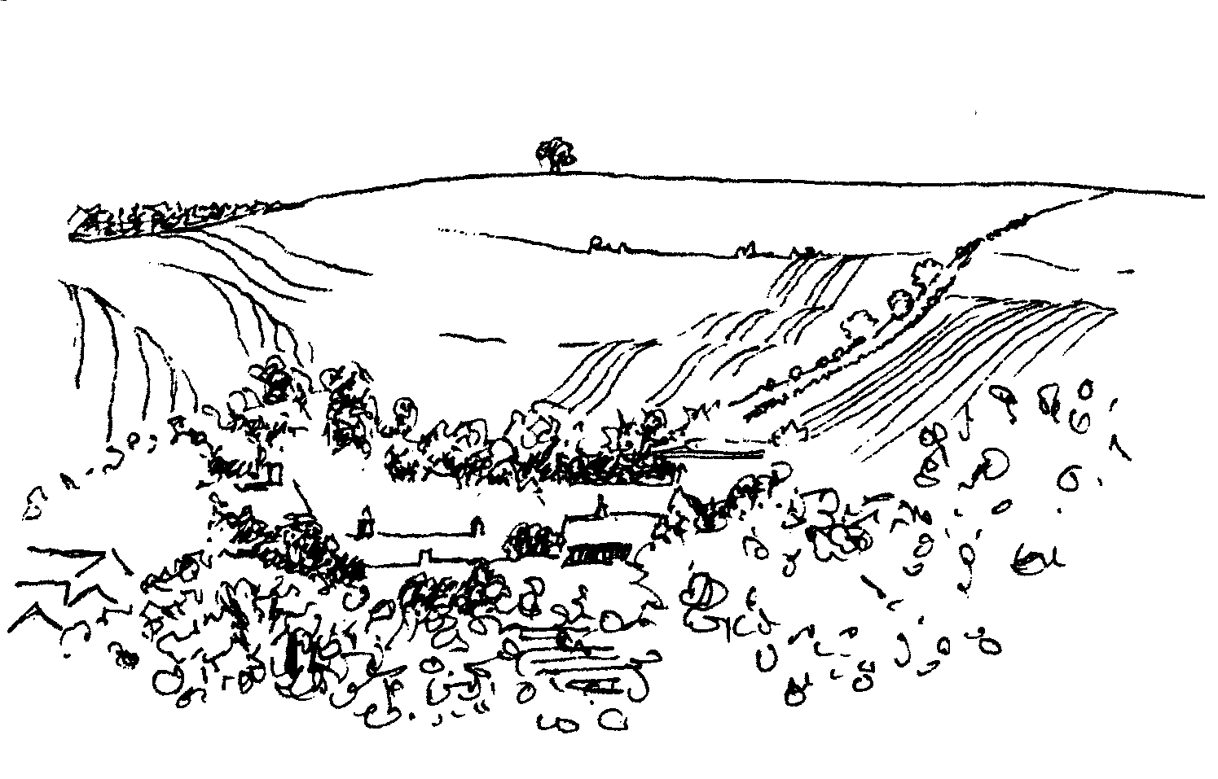
-2-

Have you ever wanted to ring church bells?
Now is your chance!
We would like to hear the Longbridge bells ringing again!
Our Tower Captain, Stephen Young, will be holding a ‘taster evening’ on Wednesday 22nd April at Longbridge Church 7.30 – 9.00pm
Come and try them for yourself - you’d be surprised!
Beginners and old hands equally welcome - just turn up!
or call Richard Munro 844385 or Stephen Young 212796 for details

Deverill Valley & Crockerton Women's Institute
Longbridge Deverill Hall - Monday 6th April 7.30 pm
Sue Wilkins of WCC Trading Standards
Postal and telephone scams
How they work and how to avoid being the victim of a scam
Please bring examples of possible scams that you may have received
For more information contact Ann Dufosee 840360

Coffee, Cards and Chat
Come and enjoy looking at the new range of cards,
ribbons, wrapping paper, and other exciting items
displayed by John and Maddie Goodden
in the Upper Deverills Village Hall on Thursday 19th February
between 10.30 and 12.00 noon - everyone is welcome
Donations will be made to the hall and the church

Annual Parochial Church Meeting
Sunday 19th April
After the Evening Service at 5.30 pm in Longbridge Deverill church
the meeting will take place at 6.00 pm in the village hall
Refreshments will be served at approximately 7.00 pm
Copies of previous minutes will be posted on each church notice board

Salisbury Theatre Club Trips
Monday 20th April
Restoration by Rose Tremain
Monday 18th May
The Importance of Being Earnest by Oscar Wilde
The cost is £17.00: theatre seat £12.00 and coach trip £5.00
Booking and payment in advance to Mary Stewart Cox Tel 840877
Longmead, Brixton Deverill, Warminster BA12 7EJ
Coach leaves Kingston Church 6.10 pm collects through the Deverills
Performances begin at 7.30 pm

-3-
From your Rector
EASTER ~ Bursting with Life!
As I write, the sun is shining, the garden is sporting patches of colour, and buds offer the promise of spring. The shops are full of Easter goodies and we are halfway through the season of Lent, about to celebrate Mothering [Refreshment] Sunday.
‘Bursting with life’ is a wonderfully appropriate Easter message, as we celebrate the resurrection. And the Church won’t be doing that only on 12th April, but through the whole Easter Season, which lasts until the end of May.
It is easy in the world of nature to see the way things ‘burst with life’. However, that is not the only way of thinking about that phrase. I have just read an article about how a major chocolate manufacturer will shortly produce its milk chocolate from fairly traded cocoa beans, which will mean that children will no longer be abducted from neighbouring countries into slave labour in the cocoa trade. Surely a sign of new life and new possibilities bursting from a tragic situation.
Engaging with our communities – which has been our focus this Lent – has generated very interesting discussions. From what has been shared, new ways of thinking about important issues, have ‘burst’ like seeds popping from a pod.
In the present downturn it is vital for us all to look for where situations burst with life and have the potential to lift us from the depths into the light and love of God.
With the first gold of dawn came a resurrection,
a new hope that grew with the rising sun,
and went out to a waiting world.
[Jean Murdoch]
May Easter blessings bursting with life be yours.
Norma Payne
Lent Talks in Salisbury Cathedral - ‘Fully Alive’
Timothy Ratcliffe gives his final address on Wednesday 1st April at 7.30 pm. I do recommend this to you, his message is constantly fresh, his book on the Eucharist is the Archbishop of Canterbury’s book for Lent.
Annual Parochial Church Meeting
Please remember to note the date of Sunday 19th April, in Longbridge Deverill Hall after evensong. See page 2.
Christian Aid week 10th to 16th May
Volunteers to help with the delivery of the envelopes in the villages and co-ordination of the collections would be very much appreciated. If you would like to help please contact Norma on 841321. In addition, envelopes will be available in the churches to be put in the collection or given to the Rector.

-4-

Upper Deverill Parish Council
The Annual Parish Meeting
This will take place on Wednesday 6th May at 7.00 pm in Upper Deverills Village Hall, followed by the Annual Council Meeting. Everyone is welcome.
Flooding in the Deverill Valley
On 13th December 2008 the river that runs through the Deverills rose several feet above its banks, flooding a number of houses in the valley and rising within inches of flooding many others, though no flood warnings had been received. The flooding caused serious problems for householders in the valley, some of whom have still not been able to return to their homes. It was a totally unexpected event as the river had never risen to these proportions within living memory or documented history. As a result in mid-February Peter Withey, from Longbridge and Crockerton Parish Council, and I met with Malcolm Munro from the Environment Agency’s (EA) Flood Risk Management team and Tim Bray, the Land Drainage Engineer for this area who works for West Wiltshire District Council (WWDC) to discuss how best to address these problems in the future.
The meeting was very informative. It appears that when the Water Act 2003 came into existence, WWDC arranged for a number of rivers in the county to be adopted by the EA; the Deverill was not included because it was viewed as an ordinary watercourse with insufficient flood risk because of its benign history. This means that the river remains primarily the responsibility of the WWDC, or more accurately from 1st April 2009, Wiltshire Council, whose powers of enforcement are rather more limited than those of the EA. The EA’s view was that the primary cause of the flooding was as described by John Robins in his article in February’s Parish News – torrential rainfall falling on frozen ground creating a faster run off than usual. Concerns that people have expressed that debris not cleared from the river was a contributory factor were seen by the EA as unlikely to have been a very significant issue. Nevertheless, we are all aware that flood risk will increase with climate change and we should be doing what we can to avoid another such event. Therefore the EA have undertaken to write to those people who own land along the river (the riparian owners), advising them what they should be doing to keep their stretch of river clear. At present the Council can use the Land Drainage Act of 1991 to oversee removal of obstructions to flow or failure to maintain the river by riparian owners. However, this is not as simple as it may seem, for example natural obstructions, such as low growing trees, often need the agreement of Natural England before they can be dealt with. As a result of the meeting, Peter and I felt that it was in the interests of the majority of householders to have the river adopted by the EA, whose information and supervisory powers of enforcement are greater than those of the Council. This would also have the benefit of having one overarching authority to deal with who could enable the liaison with other bodies, such as Natural England. It is therefore the intention of both Parish Councils to write to Wiltshire Council asking them to consider an application to DEFRA, to have the Deverill River adopted by the EA.
Trish Shuler - Upper Deverill Parish Councillor

-5-

The Deverills Cricket Club
The Deverills Cricket Club will be holding nets sessions in the indoor nets at Warminster Cricket Club, all are welcome to join us on Sunday 5th April 4.00 - 5.00 pm, Sunday 19th April 4.00 - 6.00 pm
Jamie Fagan 07796 698180
Pertwood Organic Farm Easter Experience
Come join us at the farm this Easter Sunday, we are having an open morning.
Where: Lower Pertwood Farm, The Deverills, Wiltshire, SP3 6TA
When: Sunday 12th April
What: 10.00 am – 11.00 am Home-grown, organic breakfast is served! (Pertwood Organic Mueslis, Granola and Porridge)
10.30 am Seminar on mixed organic farming at Lower Pertwood,
Chris Batchelor (Agronomist)
11.00 am – 12.00 noon The Green & Blacks Egg Hunt in the downs
12.00 noon – 1.00 pm Bird spotting guided walk RSPB, Wiltshire Branch
*Shire horse and cart rides all morning*
£3 entry per car or free on foot! Entry from the Penhill/Deverills Road entrance to Pertwood Organic Farm. We are also running a competition alongside this. Please see our website for details: www.pertwood.co.uk

Mere Bowls Club
We would welcome any new members. If you have never played, it does not matter. You do not have to be retired! Anyone from sixteen onwards is very welcome. We are holding an open session at 3.00 pm on Sunday 19th April, you need only bring a pair of flat-soled shoes, we will lend you the woods. Come to Duchy Manor School. We have practice sessions on Tuesdays and Thursdays at 6.00 pm. For more details please phone Teresa Read 01747 860209 or me Alan Inwood on 844215.
Wylye Valley Art Trail 30th May to 7th June
A reminder to put these dates in your diary and plan to visit some of the artists in the area. It is a wonderful opportunity to see a variety of work by amateur and professional artists, and a chance to talk to the artists. My ‘Look & See’ group will be exhibiting in the Kingston Deverill Village Hall and we will be pleased to see you there. The exhibition will be open daily from 10.30 am to 5.00 pm, except Thursday 4th June when we will be closed all day. The maps and full details will be available in April but you can already see them on www.wvat.co.uk If you would like more information please ring me on 840625.
Pat Armstrong

-6-
Upper Deverills Village Hall
Indian Curry Night
Saturday 18th April 7.30 pm for 8.00 pm
Bring your own liquid refreshments and glasses
Tickets £7.50 from Richard Cousins 844970
Longbridge Deverill Village Hall
St Georges Day Lunch
Sunday 26th April
12.30 pm for 1.00 pm
Two course lunch with tea and coffee
Bring your own wine
Tickets £8.00 from Sylvia Titt 214825
The Old Pottery at Bull Mill, Crockerton:
On the first Saturdays of the months - 4th April & 2nd May):
Open Studios: visitors welcome 10.00 am-4.00 pm, & by appointment
Children's Art Club: 10.30 am-12.30 pm (ages 6 upwards) £7.00
please book early
Tango Classes: 4.00 pm-7.00 pm £10.00, beginners welcome!
Yoga: Spring Term begins on 20th April with classes in Crockerton on Tuesday & Thursday evenings, Wednesday mornings
Beginners welcome!
For all details, please call Olivia and Daniel 212716
Monkey Doodle
The Creative Parent Toddler group
Mondays 9:30 – 11:30 am and Wednesdays 3:30 – 5:30 pm
at the Fane Hall, Corton
0 – 4 year olds welcome
Please come prepared to explore messy and creative play!
First session free
For more information please contact Anna Saunt on 850247
email: anna@monkeydoodle.org www.monkeydoodle.org

-7-

Upper Deverills Village Hall
Indian Curry Night Saturday 18th April
The spring tradition of a themed supper evening in the hall continues with a Curry Night starting at 7.30 pm. The curry will be served at 8.00 pm and there will be a variety of flavours available. As usual, those attending are asked to bring their own liquid refreshment and glasses. Tickets will cost £7.50 per person and are available from Richard Cousens (844970). The ticket list will close on Wednesday 15th April. Spice up your weekend and book now!
Upper Deverills Village Hall Kitchen
The response to the possibility of producing a cook book has sadly not been good. However, I must thank those few who sent me recipes and samples of the aforementioned. I enjoyed the tasters! It made me smile, the few recipes that came my way were written on all manner of materials, cardboard, copy book sheets, envelopes and Christmas cards. It reminded me of my Mother’s recipe book, hand written with recipes named after the person who had passed it on; gardening notes, old photos, pressed flowers, a packet of wallflower seeds, unused, bits cut from newspapers stuck in with sellotape, long since turned yellow and its sticky lost, a lock of golden hair. Not to mention greasy pages and tea cup circles! I hope we may be able to do something in the future with the recipes we have. Jean Warwick passed on to me a recipe book ‘Deverill Valley Recipes’ printed in 1985. Some of the contributions in it were from Lady Bath, Mrs AC Fear, Mrs Williams, Mrs Griffiths, Lady Hanley, Mrs Watkin to name a few. A delightful collection.
We are very grateful to Home Maker, in Warminster, who have promised the Kitchen Appeal an electrical item for the Summer Fete raffle. May we take this opportunity to thank them, in anticipation, for their generous gift.
With the Fete (18th July) in mind start planting your seeds for the flower and vegetable competitions, activity for the whole family, with the possibility of a prize.
Finally, please could the lady from Monkton who offered the village hall a hostess trolley give me a call as I have an incorrect phone number for her.
Dizzy Bridge 845166
Longbridge Deverill Village Hall
The Pancake evening on Shrove Tuesday was a great success. Janet, Pat and their team did sterling work over a hot stove all evening! We were rather overwhelmed by numbers and are so sorry there was sometimes a rather long wait! It was nice to see so many children, thank you all for attending.
Annual General Meeting - Wednesday 15th April at 7.00 pm
AGM and appointment of the hall committee, all members of the public are very welcome to attend and contribute to the meeting.
Sunday 26th April - St George's Day lunch - 12.30 for 1.00 pm
Enjoy a delicious two course meal, including tea and coffee, with friends to celebrate our national day. Excellent value @ £8.00 a ticket. Bring your own wine.
May/June - Open Gardens
October - John's Local Talent Music Night
Jo Nelson - chairman

-8-

SERVICES PARISH OF DEVERILLS & HORNINGSHAM
The Deverills & Horningsham Register
Baptisms at Longbridge Deverill:
Seth Hamilton on Sunday 22nd March
Finley O'Keefe-Wills on Sunday 29th March
Funeral at West Wilts Crematorium
Marjory Freda Faulkner of Hill Deverill on Friday 20th March
Sunday Palm Sunday
5th April Kingston 8.00 am Holy Communion 1662
Longbridge 10.30 am Morning Worship
Horningsham 6.30 pm Evensong
Thursday Maundy Thursday
9th April Longbridge 7.30 pm Holy Communion
Friday Good Friday
10th April Horningsham 10.00-11.30 am Workshop - village hall
Brixton 11.00 am Stainer’s Crucifixion
Brixton 12.00 noon Good Friday Service
Sunday Easter Day
12th April Kingston 10.30 am Holy Communion
Horningsham 11.15 am Holy Communion
Sunday 2nd after Easter
19th April Brixton 10.30 am Holy Communion
Longbridge 5.30 pm Evening Prayer
Longbridge Hall 6.00 pm APCM
Sunday 3rd after Easter
26th April Longbridge 10.30 am Holy Communion
Horningsham 11.15 am Morning Prayer
Brixton 6.00 pm Evening Prayer
Sunday 4th after Easter
3rd May Brixton 8.00 am Holy Communion 1662
Longbridge 10.30 am Morning Worship
Tuesday, Wednesday, Thursday, Friday
Longbridge 8.30 am Morning Prayer
Wednesday
Longbridge 10.15 am Holy Communion

-9-
SERVICES PARISH OF CORSLEY & CHAPMANSLADE

Ivy House St Denys Retreat Centre
A place for rest, refreshment and renewal

Sunday 5th April - Lunch & Quiet Afternoon
‘The Palm Sunday story through Godly Play’
with the Reverend Jean Thorn
Cost: £16.00 including coffee, lunch and tea
For more information please phone 214824
Contact the Clergy
Please contact Norma Payne (841321) or Di Britten (01373 832515) if anyone is housebound and would like communion or a visit at home; or if someone is ill and needs our prayers; or to discuss any church matter.
Office administrator phone 210149 or email: office@cleyhill-team.org.uk

Sunday Palm Sunday
5th April Corsley 9.00 am Holy Communion
Thursday Maundy Thursday
9th April Chapmanslade 7.30 pm Agape
Friday Good Friday
10th April Chapmanslade to Corsley Walk
10.00-12.00 noon
Corsley 12.15 pm Good Friday Service
Sunday Easter Day
12th April Temple 9.00 am Holy Communion 1662
Chapmanslade 10.30 am Holy Communion
Sunday 2nd after Easter
19th April Chapmanslade 9.00 am Holy Communion
Corsley 6.00 pm Evening Worship

Sunday 3rd after Easter
26th April Temple 9.00 am Holy Communion 1662
Corsley 10.30 am Parish Service

Sunday 4th after Easter
3rd May Chapmanslade 9.00 am Patronal Festival

-10-
Low-energy light bulbs
Like us, others may have noticed press coverage on the dangers of low-energy light bulbs as they contain a small amount of mercury. Unlike us, you may already be aware that if a low-energy bulb is accidentally broken, a certain amount of care should be exercised in cleaning up and disposing of it. The Defra website gives full details - go to Defra Low-Energy Light Bulbs, then Q & A, Mercury in Energy Saving Light Bulbs, but the essence of the information is:
Vacate the room and ventilate it for at least 15 minutes. Do not use a vacuum cleaner, but clean up using rubber gloves and aim to avoid creating and inhaling airborne dust. Sweep up all particles and glass fragments and place in a plastic bag. Wipe the area with a damp cloth, then add that to the bag and seal it. Mercury is hazardous waste and should not be disposed of in the bin. All local councils have an obligation to make arrangements for the disposal of hazardous household waste.
Even unbroken but no longer working CFL's (compact fluorescent light bulbs) should be disposed of as hazardous waste to avoid mercury leaching from landfill sites into groundwater, etc. However, despite the above caveats, no-one should be put off using CFL's in view of the critical need to reduce carbon emissions.
Simon & Mandy Martyn

Church Cleaners for April
Kingston – Mrs Martyn & Mrs Shuler
Brixton - Mrs Hammick & Mrs Abraham
Longbridge - Monday 6th April 9.30 - 10.30 am - all helpers please
Church Flower Arrangers for February
 | Kingston | Brixton | Longbridge
5th April | Lent | No | Flowers
12th April | All helpers | All Helpers | Mrs Hurd + helpers
19 April | Mrs Stratton | Mrs Hammick | Mrs Hurd + helpers
26 April | Mrs Royall | Mrs Hammick | Mrs Hurd + helpers

CONTACT THE EDITOR AND WEBSITE
Parish News Editor - Judy Munro 844385
Contributions for the Parish News through my letterbox or
by post to Whitepits Lodge, Kingston Deverill, Warminster,
BA12 7HD or by Email: judymunro@tiscali.co.uk Thank you
Please remember the deadline is the 15th of every month

Website: www.deverills.org.uk Email address:info@deverills.org.uk
Website manager : Kate Wilkinson 844998
Contents: Parish News with church services, Parish Register, Events, Local News plus pictures and other information
-11-

Broadband in the Upper Deverills
Broadband questionnaires were delivered to the 150 homes within the 3 villages with the February edition of the Parish News. 57 were completed and returned revealing that 46 were broadband users. Ofcom have stated that average rural penetration in the UK is 59% so, using this figure, in theory 89 of our 150 homes should have broadband. Hence the response to the questionnaire was 52%, considered by the Action Group to be a satisfactory response to a survey of this type. Analysis has since shown:
Major dissatisfaction with speed: only 6 users exceeded 1Mbps download speed
Dissatisfaction with reliability: 43% recorded this
Concern about cost, in particular high cost for poor service; a view is that where poor service exists users should pay less than those receiving a full service
Clearly the inadequacies associated with the exchanges of both Sutton Veny (serving Brixton) and Maiden Bradley (serving both Kingston and Monkton) are major factors contributing to the problems being experienced. Reports have been written and distributed to both BT at SW Regional level and a letter enclosing the documents has also been sent by Upper Deverill Parish Council to the Department for Culture, Media and Sport and the Department for Business, Enterprise and Regulatory Reform in response to their report Digital Britain - The Interim Report. We were able to get our findings to them within the deadline they set for responses.
The full Action Group report and spreadsheet can be seen on the Deverills and Crockerton website: www.deverills.org.uk. We now await a response from BT.
Robin Greenwood 840743

Neighbourhood Watch
May I introduce myself, I am Inspector Dave Minty and I am the sector Head for the Warminster area, and would like to assure you of my commitment to supporting Neighbourhood Watch. It is a vital tool in both the reduction and detection of crime. The Warminster area is currently doing much better than its targets in reducing and detecting crime, I believe we wouldn't be so successful without your support. There are soon to be some changes in the manner in which the rural areas are policed, instead of three separate Neighbourhood teams we will have one. This will be lead by PC Pegrum with the support of two PCSO's. To assist her Warminster will be getting a dedicated Neighbourhood sergeant, allowing for robust supervision, ensuring that the priorities of the NPT are undertaken. PC's Bridge and Faulkner will not be leaving but will be rejoining the response shifts, so we will be able to guarantee PC Pegrum is not abstracted from her role for more than 20% of the time; we will publish her abstraction rate for you to see how much time she is spending on community issues. I believe the changes will provide better service with an officer dedicated to the area and able to deal with issues that really matter within the community. If you would like to contact PC Pegrum see details on page 14. Thank you for your support.
Dave Minty - Sector Inspector, Warminster
PC Phil Bridge has enjoyed his role as Rural Community Beat Officer, meeting some very nice folk in the villages who he will still see covering response shifts.

-12-

Thank you
We are very grateful to Roy Andrews who has distributed the Parish News around the villages each month in recent years for volunteers to deliver. Sadly he has had to retire, so we thank him for all his hard work and dedication. We are very grateful to Dianna Abbott who has come forward to take on the role of distribution.
Judy Munro - Editor
Nature Notes
Some days when I go for a walk I don’t see anything worth noting but then other days I hit the jackpot with sightings. Today was a jackpot day, I went out into the garden and there was a party of long-tailed tits about, always a joy to see. I left the garden and went out through the yard and started to walk up the track at the back. No sooner had I started to walk I was stopped in my tracks as ‘our’ kestrel flew away from me very low with laboured wing beats. He didn’t fly far and landed just below the box that we have for him and his potential mate. I got the binoculars on him and watched. He stood motionless but I sensed that he was checking about him for any signs of trouble. After a short time he spread his wings, i.e. mantled, dropped his head down and started eating whatever he had just caught which must have been fairly heavy judging by his inability to gain height! I decided to change my planned route so as not to disturb his meal, and retraced my steps back through the yard. As I walked along I caught sight of something reddish-brown out in the field just behind our house. I readjusted the binoculars and sure enough it was a hare. I looked around for any more and yes there was a second, and a third and then a fourth came running from the ditch. I watched hoping and bingo two interacted and did a quick burst of boxing and jumping over one another, brilliant. I think I worked out what was happening. There was one larger hare which was the female, and she was fending off a potential male suitor hence the boxing and dancing about. The other two hares were also smaller and as I watched all three ‘lads’ ran off, chasing after one another. Then I heard a ‘chronk’ above me and, looking up, saw a raven flying over me towards the wood. All this happened in about 10 minutes!
We’ve had a pair of siskins in the garden for nearly two weeks now. Usually I find that they come for a day and then disappear, but this pair seem to have decided that the restaurant here is worth staying around for! They are very pretty birds and quite small, about the size of a blue tit. The male is more strikingly coloured than the female, as with most birds, but both display a lovely array of olive green shades. As well as being more vivid in colour the male has a distinguishing black crown on the head. They are a great addition to the garden bird list.
I have recently seen little egrets flying up our valley, they appear to be taking the wrong turning and going right in front of The George rather than going up the Deverill valley with the river! Unless they are joining the great number of birds feeding on the newly cultivated fields up the road? I counted 27 buzzards up there just over a week ago, along with numerous fieldfares, starlings and various corvids.
Jane Trollope (written on 14th March)
First reported swallows in the Deverills by Alison Rymell in Brixton on 18th March.

-13-
Where have you been?
The Udder Farm Shop and Restaurant
(01747 838899/www.theudderfarmshop.co.uk)
Just the name alone of this lovely farm shop and restaurant would make you want to visit it! I went there for lunch with a friend in early March, having had it mentioned to me more than once by people in the valley. I was really impressed by the amount of local foodstuffs they had on sale, plus some quirky food-based gift items. The shop has a fresh meat counter staffed by three butchers, a greengrocery, a frozen foods section and a bakery, which sells bread and cakes made daily. They also sell, unsurprisingly, milk and cream from their own dairy and from local dairy producers in the Blackmore Vale. There is a delicatessen counter too which sells UK cheeses. It is situated on the A30 between Gillingham and Shaftesbury (near East Stour). When I went for lunch it was mid-week but still quite busy. Fortunately my friend had the foresight to book us a table because the restaurant soon filled up. The food was excellent and, if forewarned, caters very well for dietary restrictions. It has an extensive menu and also serves wine. The restaurant and coffee shop opened in January 2008; it is a large open area with marvellous views of the Blackmore Vale. I thought the menu had plenty of choice on it and the staff were both knowledgeable and obliging. They are open from Monday to Saturday 8.30 am to 6.00 pm and Sunday from 10.00 am - 4.00 pm. I believe it is very popular for Sunday lunch.
If you have somewhere you would like to recommend, please send your comments and suggestions to me by email at farthings.kd@btinternet.com or through my letter box at Farthings, Kingston Deverill.
Trish Shuler
Recipe of the Month - Chocolate Fridge Cake
Ingredients (makes about 12-16 pieces)
180 g / 6½ oz raisins 1½ table spoons golden syrup
120 ml / 4 fl oz liqueur or orange juice 180 g / 6½ oz glaceˊ cherries, halved
300 g / 10½ oz dark choc. (70%) pieces 225 g / 8 oz digestive biscuits
180 g / 6½ oz unsalted butter, diced Icing sugar for dusting
Method
1. Place the raisins in a small saucepan with the liqueur or orange juice, simmer until it is almost completely absorbed, stirring occasionally. Leave to cool for 15 – 30 minutes while they absorb the remainder.
2. Gently melt the chocolate, butter and syrup in a large bowl set over a sauce pan of simmering water, stirring until smooth.
3. Stir in the raisins, cherries and broken up biscuit, coat with chocolate mixture.
4. Line the base of a 23 cm/9 inch square tin with non-stick baking paper and spoon the mixture into it. Smooth the top over with a palette knife.
5. Chill for 2-3 hours until hard. Run a knife around the edge of the tin to remove the biscuit, lift off paper. Place upwards on a board and dust with icing sugar.
6. Cut into squares or fingers of your choice. Store in an airtight container in the fridge. It will keep for a least a week.

This recipe is sponsored by Maiden Bradley Community Shop (844206)

-14-

LOCAL COUNCILS, SOCIETIES, GROUPS etc.
Longbridge and Crockerton Parish Council
Karen Manfield 215526 (Chair) Peter Whithey 840347 (Vice Chair)
Helen Few 840119 (Clerk) Thomas Minter 216909
Bill Hurd 840023 Elaine Pidgeon 212878
Julian Algar 840816 Graham Read 840296
Brian Marshall 214789
Upper Deverills Parish Council
Lady Felicity Wheeler 844683 (Chair) Ranald Blue 841374
Jacqueline Smith 840238 (Clerk) Patricia Shuler 844291
Sarah Fagan 844123 Robin Greenwood 840743
District Councillor
Shear Water Ward - Michael Mounde 844363

Longbridge Deverill Village Hall Committee
Jo Nelson 840784 (Chair)
Barbara Smith 840251 (Secretary) Sylvia Titt 214825 (Caretaker)

Upper Deverills Village Hall
Richard Cousens 844970 (Chair)
Mandy Martyn 844320 (Secretary) John Lea 844325 (Hall bookings)

Crockerton Millennium Committee
Marion Thomas 213739 (Chair)

Pre-School Children and Parents ‘Thursday Group’
Barbara Beilby 844995 (Chair) Sylvia Titt 214825 (Leader)

Deverill Valley & Crockerton W I
Ruth Sutton (President) Jill Russell 840209 (Secretary)

Sir James Thynne Almshouse
Mrs Sue Jackson 840322 (Steward)

Deverills Cricket Club
Jamie Fagan 844123 Peter Child 01963 34593

Wylye Valley Tennis Club
Colin Singer 213696

Wylye Valley Flower Club
Mrs Hazel Yate 215617 (President) Mrs S Scott 213689 (Programme Secretary)

Wiltshire Wildlife Trust
Elm Tree Court, Long Street, Devizes SN10 1NJ www.wiltshirewildlife.org

Rural Community Beat Officer - Police Community Support Officers
PC Vicky Pegrum - PCSOs Ian Owen & Caroline Wright - 0845 408 7000

Hospital Transport Link Scheme 211655

-15-

F O R T H C O M I N G E V E N T S
F O R T H C O M I N G E V E N T S

- Hearing Loss Lip-reading Wednesdays Margaret Head (213259)
- Scottish Dancing Monday Evenings Aline Fry (841054)
- Badminton Mondays & Fridays 3.00 - 5.00 pm Alison Rymell (844819)
- Pre-school & Parents Group Thursdays 10.00 - 11.30 am See p14
- Fully Alive talks Wednesday 1st April See p3
- Old Pottery at Bull Mill Activities Saturday 4th April See p6
- Ivy House Quiet Day Sunday 5th April See p9
- Deverills Cricket Club Nets Sunday 5th April See p5
- Women’s Institute Annual Meeting Monday 6th April See p2
- Lower Pertwood Open Farm Day Sunday 12th April See p5
- Wylye Valley Flower Club ‘Pots of Fun’ Tuesday 14th April See p14
- Longbridge Deverill Village Hall AGM Wednesday 15th April See p7
- Indian Curry Night Saturday 18th April See p6/7
- Mere Bowls Club Sunday 19th April See p5
- Deverills Cricket Club Nets Sunday 19th April See p5
- Annual Parochial Church Meeting Sunday 19th April See p2/3
- Yoga Classes Spring Term begins Monday 20th April See p6
- Salisbury Theatre Club Monday 20th April See p2
- Bell Ringing Wednesday 22nd April See p2
- St George's Day lunch Sunday 26th April See p6/7
- Old Pottery at Bull Mill Activities Saturday 2nd May See p6
- Longbridge & Crockerton Parish Council meeting 7.30 pm Tuesday 5th May at Longbridge Village Hall See 14
- Upper Deverills Parish Council Annual Meeting 7.30 pm Wednesday 6th May Upper Deverills Village Hall See p4/14
- Christian Aid Week 10th - 16th May See p3
- Salisbury Theatre Club Monday 18th May See p2
- Wylye Valley Art Trail Saturday 30th May – Sunday 7th June See p5

F O R T H C O M I N G E V E N T S
16-
PARISH OF THE DEVERILLS AND HORNINGSHAM
Churches
SS Peter & Paul the Apostles Longbridge Deverill (LD)
St Michael the Archangel Brixton Deverill (BD)
St Mary the Virgin Kingston Deverill (KD)
St John the Baptist Horningsham (H)
Rector
Rev Norma Payne, 6 Homefields, Longbridge Deverill 841321
Clergy
Rev Diana Britten, 69 Lane End, Corsley01373 01373 832515
Licensed Lay Ministers
Mr John Budgen, Woodlands, Sutton End, Crockerton 218203
Col Robin Chappell, 7 Elm Hill, Warminster 212153
Churchwardens
Mrs Elisabeth Atkinson, 133 Foxholes, Crockerton (LD) 212129
Mr Nigel Poole, 7 Homefields, Longbridge Deverill (LD) 840902
Mrs Mary Stewart Cox, Longmead, Brixton Deverill (BD) 840877
Major Mike Tulloch, Spring Cottage, Monkton Deverill (KD) 844381
Mr Tim Moore, Manor House, Church Lane, Horningsham (H) 844336
Lay Pastoral Assistant Co-ordinator
Rev Norma Payne, 6 Homefields, Longbridge Deverill 84l321
PCC Treasurer
Mr David Stratton, Manor Farm, Kingston Deverill 844549
PCC Secretary
Mrs Anne Honley, Dry Hill House, Crockerton 215956
Church Electoral Roll Officer
Major Mike Tulloch, Spring Cottage, Monkton Deverill 844381
Parish News Editor
Mrs Judy Munro, Whitepits Lodge, Kingston Deverill 844385
Organist
Mr John Budgen, Woodlands, Sutton End, Crockerton 218203
Tower Captain
Mr Stephen Young, 68 Highbury Park, Warminster 212796
Caretaker - Longbridge Church
Mrs Sylvia Titt, 7 Church Street, Longbridge Deverill 214825
Office Administrator (Mon -Thurs 10.00 - 12.00)
Mr Dick Collins, 22 Church Street, Warminster 210149

